 | Enterprise Management and Business Insight  https://jurnal.edumedia.co.id/index.php/embi
Vol., No.1, 2024
e-ISSN: xxxx - xxxx

Title should be Concise and Indicate the Novelty of the Research: Not Exceeding 15 words (16 font)
Author Name¹, Author Name², (11 font bold center)
^{1,2,} Affiliation (Faculty, University, Country)
Email Corresponding author: xxxxxxx@xxx.xx

ARTICLE INFO |  | ABSTRACT
  Article history:  Received:  Revised:  Accepted:  Keywords: separated using; (semicolon), 5 words maximum |  | The abstract should be clear and informative in one paragraph (between 150 and 250 words). Use Calibri font in size 10-pt with single spacing. It should succinctly describe your entire paper which contains the introduction indicating the research gap, purpose, methodology, findings, conclusion, and research implication/contribution. It should tell the prospective readers what you did and highlight the key findings. Avoid using technical jargon and uncommon abbreviations. The abstract must appear on the top of the first page after the title, author(s). The email address of corresponding author (who will handle correspondence at all stages of refereeing and publication, also post-publication; this responsibility includes answering any future queries about Methodology and Materials) of the paper.  Keywords are the labels of your manuscript and critical to correct indexing and searching. They should be well selected and closely related to the topic to facilitate readers’ search and should represent the content of your article. Use only abbreviations that are firmly established in the field. There must be 3-7 keywords (phrases). Each phrase in Keywords should be separated by a semicolon (;).

INTRODUCTION (First Heading)
It is how you must present your Introduction. The article structure contains (a) Title; (b) Author(s) name, affiliation, and email address of corresponding author; (c) Abstract; (d) Keywords; (e) Introduction); (f) Method; (g) Results; (h) Discussion; (i) Conclusion); (j) Funding; (k) References; and (l) Appendices (if any). Therefore, the article should clearly describe the background of the subject, the author's work, including the method used, results, and concluding discussion on the importance of the work.
Manuscripts should be typed in MS Word doc. format; using 12-pt Calibri font; space 1,15, left, right, top, and bottom margins are 2,2 cm; single-spaced on A4-sized paper; length: between 4,000 and 7,500 words (including tables, figures, references, and appendices). It is expected that the author will submit carefully written and proofread material.
Use Reference Management Software such as Zotero (http://www.zotero.org), Mendeley (https://www.mendeley.com), etc. for citations and references by following the style of the American Psychological Association (APA) 7th Edition. Careful checking for spelling and grammatical errors should be performed.
The introduction should clearly state the purpose of the paper. It includes a review of related literature and research purpose in essay style. The introduction should include key references to appropriate work. It states the significant contribution of the research. All introductions should be presented in the form of paragraphs, not pointers, and with the proportion of 15-20% of the whole article’s length.
Author should provide an adequate background, and literatures review or to record the existing solutions/method, to show which is the best of previous studies, to show the main limitation of the previous studies, to show what do you hope to achieve (to solve the limitation), and to show the scientific merit or novelties of the paper. Avoid a detailed literature review or a summary of the results. Do not describe literatures review as author by author but it should be presented as group of articles per method or topic reviewed which refers to some literatures.
At the end of the introduction, the author should explicitly state the research gaps and show the novelty of the research. Authors should also write the research questions or research objectives and the research contributions. Here are the examples of the gaps analysis statement at the end of Introduction section: “........ (short summary of background) ............ (put here state of the art or overview of previous researches similar to this research) .............. A few researchers focused on ....... There have been limited studies concerned on ........ Therefore, this research intends to ................. The objectives of this research are .........”.

or

“........ (Short summary of background) ............ (put here state of the art or overview of previous researches similar to this research) .............. A few researchers focused on ....... There is no researcher concerned on ........ Therefore, this research focuses on ................. This research is aimed to .........”. Then, the research contribution should be written here.

LITERATURE REVIEW (First Heading)
The literature review represents the theoretical core of an article. In this section, we will discuss the purpose of a literature review. We will also consider how one should go about to find appropriate literature on which to base a literature review and how this information should be managed. Finally, we will answer four questions that first-time researchers often battle with when compiling a literature review.
The literature review represents the theoretical core of an article. In this section, we will discuss the purpose of a literature review. We will also consider how one should go about to find appropriate literature on which to base a literature review and how this information should be managed. Finally, we will answer four questions that first-time researchers often battle with when compiling a literature review.
These questions are: which aspects should I include in a literature review?; how should I go about synthesizing information in a literature review?; how should I structure a literature review? what writing style should I use when compiling a literature review?
The purpose of a literature review is to “look again” (re + view) at what other researchers have done regarding a specific topic (Leedy & Ormrod 2005:70). A literature review is a means to an end, namely to provide background to and serve as motivation for the objectives and hypotheses that guide your own research (Perry et al. 2003:660)
A good literature review does not merely summarise relevant previous research. In the literature review, the researcher critically evaluates, re-organizes and synthesizes the work of others (Leedy & Ormrod, 2005:84). In a sense, compiling a literature review is like making a smoothie or fruit shake: The end product is a condensed mix that differs totally in appearance from the individual ingredients used as inputs. The key to a successful literature review lies in your ability to “digest” information from different sources, critically evaluate it and resent your conclusions in a concise, logical and reader-friendly” manner.
First-time researchers often naively believe everything they read or are scared to criticize the work of others. However, academic research is all about critical inquiry! It is, therefore, extremely important that you critically evaluate the material that you read. Do you agree with the arguments and conclusions of other researchers? If you disagree, why? Can you identify contradictory arguments or findings? How could one explain these contradictions? Do the findings of previous studies apply in all contexts or are the findings context-specific? What are the criticisms against the conceptual models or measurement approaches discussed in the literature? Which limitations should be considered when interpreting the results of previous research?
You have to carefully read the most recent available literature to identify specific gaps, inconsistencies and/or controversies that may form the basis of your own research. Always show that you have considered an issue from several angles and that you are aware of the arguments for and against a specific point of view. Many researchers in services marketing, for example, use the SERVQUAL measurement scale without considering existing criticisms against it.
To compile a proper literature review, one has to overcome three specific challenges, namely: finding appropriate literature on a specific topic, managing the information, and presenting a logical, synthesized, and reader-friendly review of the current knowledge relating to a specific topic. Consider the following search strategies: Blackwell Synergy; Proquest Data Basis; EBSCOhost (Business Source Premier and Business Source Premier); Emerald; Taylor and Francis; Infotrac; Wiley Interscience; and others open access journal using Google Scholar

METHOD (First Heading)
This section discusses the research methodology. This section consists of several subsections telling about the research method description such as the research design, participants/sample selection and data sources, instrumentation/data collection (practical procedures), and data analysis/estimating model (practical procedures). Methods already published should be indicated by a reference: only relevant modifications should be described. Do not repeat the details of established methods.
Research Design (Second Heading)
Under this section, you must present a description about the selected research method. Begin this section with the aims of your research and provide an explanation on why the research method is appropriate to your work as well as its nature and characteristics.
Participants/Sample Selection and Data Sources (Second Heading)
Under this section, you must explain who your participants are, how you get to them, what types of data, and the sources of the data.
Instrumentation/Data Collection (Second Heading)
Under this section, you have to present the instruments you use and how you obtain the data in procedural ways.
Data Analysis/Estimating Model/Variable Measurement (Second Heading)
Under this section, you have to present the procedural steps of data analysis, how you ensure the validity and reliability, as well as how you measure the variables of your research.
RESULT (First Heading)
This section deals with the research findings. The findings obtained from the research must be supported by sufficient data. The research results and the discovery must be the answers, or the research hypothesis stated previously in the introduction part. The findings section consists of a description of the results of the data analysis to answer the research question(s). The findings should summarize (scientific) findings rather than providing data in detail. Each table, figure, or interview data should be accompanied by a paragraph explaining and describing the table, figure, or interview data. Don’t make your table, figure, or interview data stand-alone without description and interpretation. See how figures, table, and interview data are presented.

Figure :
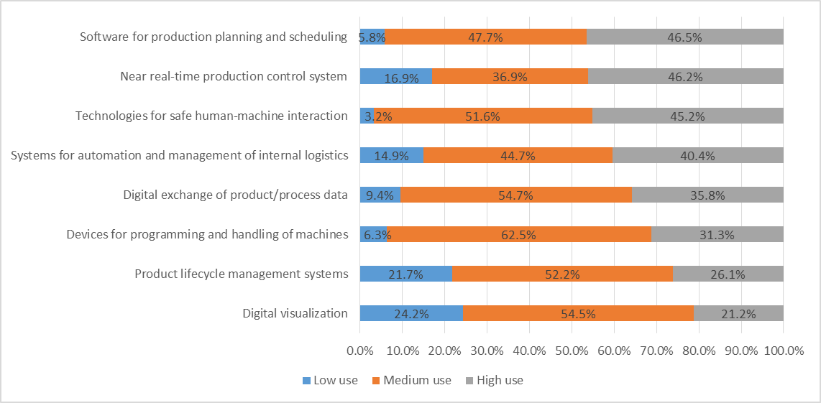
figure 1. Curves IS
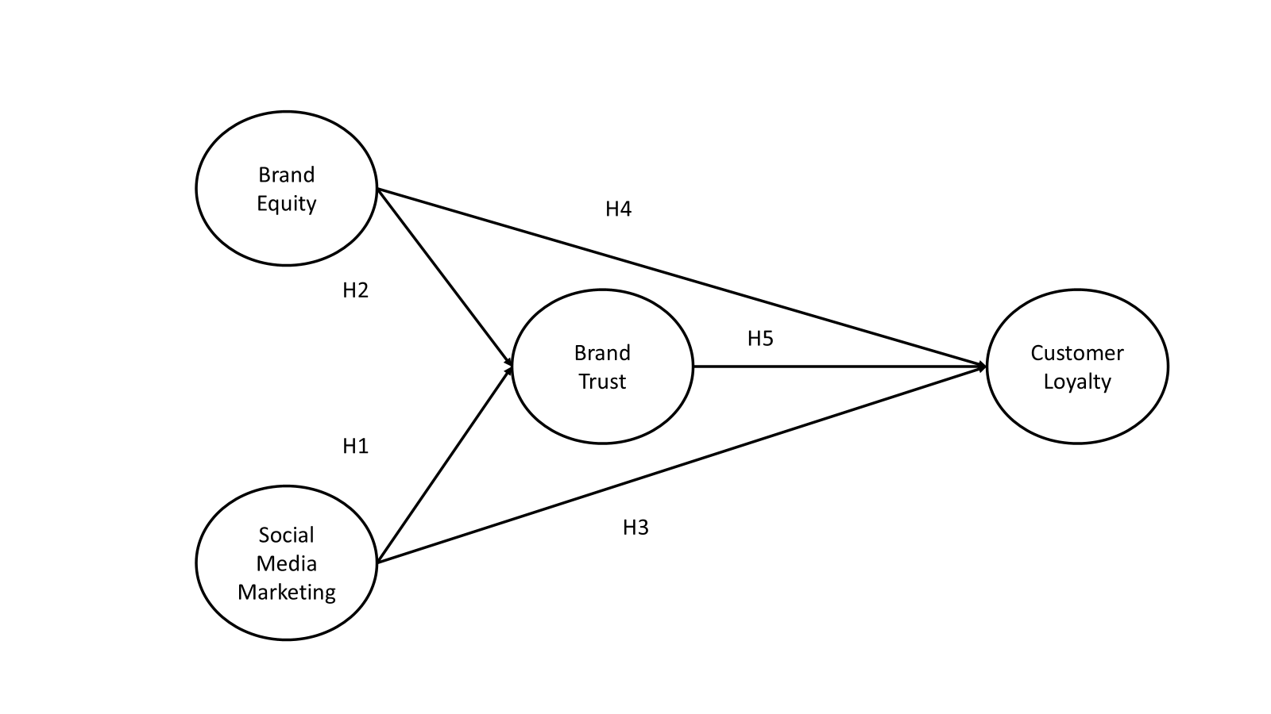
Figure 2: Schematic Diagram of the Study
Tables :
Tables should be arranged consecutively (e.g., Table 1, etc.). The caption should be (center justified) and placed above, as like the following example.
Table 1. The Growth of Islamic Banks
Group of Banks |  | 2013 | 2014 | 2015 | 2016 | 2017
Islamic Banks |  | 11 | 12 | 12 | 13 | 13
Conventional Banks |  | 120 | 119 | 118 | 116 | 115
Islamic Business Units |  | 23 | 22 | 22 | 21 | 21
Islamic Rural Banks |  | 163 | 163 | 163 | 166 | 167
Source: Indonesia Banking Statistics 2013-2017, processed

Mathematical Formula
Mathematical formulas should be numbered and clearly presented using microssoft
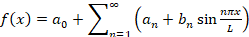 (1)
DISCUSSION (First Heading)
This section deals with the discussion of the research findings. In the Discussion section, the author should present it with a detailed explanation in several subsections (it depends on the needs). The discussion should explore the significance of the results of the work, not repeat them. In the discussion, it is the most important section of your article. Here you get the chance to sell your data. Make the discussion correspond to the results, but do not reiterate the results. Often should begin with a summary of the main scientific findings. The meanings of the findings should be shown from current theories and references of the area addressed.
In the discussion section, you are comparing and contrasting the findings of the current research with those from the previous research or the supporting theories. There should be a similarity and contrast analysis. The following components should be covered in discussion: (a) How do your results relate to the original question or objectives outlined in the Introduction section? What is your finding of research? (what/how)? (b) Do you provide interpretation scientifically for each of your results or findings presented (why)? This scientific interpretation must be supported by valid analysis and characterization (why)? (c) Are your results consistent with what other investigators have reported (what else)? Or are there any differences?
At the end of the Discussion section, there should be a closing statement of the discussion.

CONCLUSION (First Heading)
It contains conclusion and suggestion. Conclusion briefly illustrates the results that address the hypotheses and/or research purposes or findings. It is the summary of the research and discussion, relevant to the findings, presented descriptively, not numeric. Suggestion provides things expected to conduct related to further ideas the research has proposed.

ACKNOWLEDGMENT (First Heading)
Recognize those who helped in the research, especially funding supporter of your research. Include individuals who have assisted you in your study: Advisors, Financial supporters, or may other supporter i.e. Proofreaders, Typists, and Suppliers who may have given materials.

REFERENCES (First Heading)
Citations and references must strictly follow APA 7 (American Psychological Association) style with DOI NUMBER. References should relate only to the content that is cited within the text of the manuscript. Consulting the APA style manual (http://www.apastyle.org/pubmanual.html) is highly recommended for compiling manuscript submissions.

Bahari, N., Yunus, A. R., Jabar, J. A., & Yusof, S. W. M. (2018). Entrepreneur Characteristics and Firm Performance: A Study on Malaysian Food Manufacturing Industry Sme’s. IOSR Journal Of Humanities And Social Science (IOSR-JHSS), 23(2), PP 92-98. https://doi.org/10.9790/0837-2302079298
Iskamto, D. (2021). Stress and Its Impact on Employee Performance. International Journal of Social and Management Studies, 2, 142–148. https://doi.org/10.5555/ijosmas.v2i3.42
Laguna, M., Wiechetek, M., & Talik, W. (2012). Competencies of Managers and Their Business Success. Central European Business Review, 1(3), 7–13. https://doi.org/10.18267/j.cebr.25
Riewe, M., & Université de Liège > Master ingé. gest., À. F. (2020). Development of an incentive system and steering tool in the operating room management. https://matheo.uliege.be/handle/2268.2/8680
Sajilan, S., & Tehseen, S. (2015). Cultural Orientations, Entrepreneurial Competencies and SMEs Business Success: The Contingent Roles of Environmental Turbulence and Network Competence. Society of Interdisciplinary Business Research, 4, 16.
Rosyadhi, R. I., & Salim, A. (2022). Islamic Economic Perspective and Potential of Zakah Imposement on Cryptocurrency. Journal of Islamic Economic Laws, 5(1), 61–83. https://doi.org/10.23917/jisel.v5i1.17204
Selcuk, M., & Kaya, S. (2021). A Critical Analysis of Cryptocurrencies from an Islamic Jurisprudence Perspective. Turkish Journal of Islamic Economics, 8(1), 137–152. https://doi.org/10.26414/a130
Widarto, A. R., Muharam, H., Wahyudi, S., & Pangestuti, I. R. D. (2022). ASEAN-5 and Crypto Hedge Fund: Dynamic Portfolio Approach. SAGE Open, 12(2). https://doi.org/10.1177/21582440221094612

